CSD 420 Advanced Java Programming
Module 4 Programming Assignment LinkedList Traversal Timing
Zachary White
Darrell Payne
August 27, 2026

Overview
This assignment compares two ways of traversing a java.util.LinkedList: using an Iterator versus using the get(index) method inside a standard indexed for-loop. The test program (LinkedListTimingTest.java) builds a LinkedList<Integer> and times both traversal approaches, first with 50,000 elements and then with 500,000 elements, so the two approaches can be compared both against each other and across list sizes. A separate correctness check confirms both traversal methods visit every element and produce the expected sum before any timing numbers are trusted.

Program Output
The screenshot below shows the program being compiled with javac and executed with java from the command prompt, along with the recorded traversal times for both the 50,000-element and 500,000-element lists, as well as the output of the correctness check.
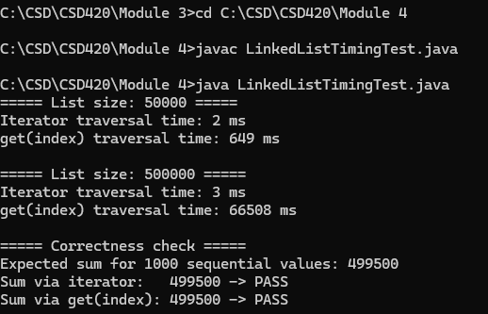
Figure 1. Command-line compilation and execution of LinkedListTimingTest.java

Results
List size: 50,000 | Iterator traversal: 2 ms. get(index) traversal: 649 ms.
List size: 500,000 | Iterator traversal: 3 ms. get(index) traversal: 66,508 ms.

Discussion
A LinkedList in Java is a doubly linked list, not a resizable array, so there is no way to jump straight to a given position the way an ArrayList can. Each call to get(index) has to start from whichever end of the list is closer and step through the list node by node until it reaches the requested index. That makes a single get(index) call an O(n) operation in the worst case. Calling get(index) inside a for-loop that runs once per element pays that O(n) cost on every iteration, making the entire traversal O(n^2). An Iterator instead keeps a direct reference to the current node and simply follows the next pointer, so each call to next() is O(1) and a full traversal with an iterator is O(n) overall.
The measured results confirm this. At 50,000 elements, the iterator finished the traversal in 2 ms while get(index) took 649 ms, roughly 300 times slower for the same traversal. At 500,000 elements, the iterator's time only grew to 3 ms, which lines up with the expected linear, O(n) growth: a 10x increase in list size produced only a small, proportional increase in traversal time. The get(index) approach, by contrast, grew from 649 ms to 66,508 ms, an increase of roughly 102 times, which closely matches the theoretical expectation: because both the number of loop iterations and the average cost of each individual get() call increase as the list grows, a 10x increase in list size (50,000 to 500,000) for an O(n^2) algorithm should produce roughly a 100x increase in running time rather than a 10x increase. The measured 102x increase confirms that get(index) traversal on a LinkedList behaves quadratically, exactly as expected.
The overall conclusion is that get(index) should be avoided when repeatedly traversing a LinkedList, since its cost grows quadratically with list size. An Iterator (or an enhanced for-loop, which uses an iterator internally) should be used instead whenever every element needs to be visited in order. The get(index) method remains useful on a LinkedList only for a single, occasional lookup, not for scanning the whole list.

Testing for Correctness
Separately from the timing runs, I decided to build a smaller 1,000-element LinkedList and sums its contents using both the iterator and the get(index) approach to get a control volume to see the tool in action, I then compared each sum against the mathematically expected value (the sum of 0 through 999, which is 499,500). As shown in the console output above, both the iterator sum and the get(index) sum came out to 499,500 and were reported as PASS, confirming that both traversal methods correctly visited every element in the list before their relative speed was compared.

Sources
Liang, Y. D. (2023). Introduction to Java programming and data structures (13th ed.). Pearson.
Related Coursework Material via Module 4 ( Bellevue University )

